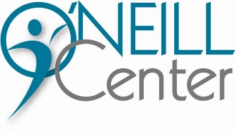

February 13, 2025

Dear Friends:

The O’Neill Center would like to invite you to take part in our annual health fair. The goal of the event is to help the seniors gain knowledge about resources that will allow them to continue living H.I.P: Healthy, Independent and Productive lives. We look forward to working with you to provide the seniors with education on health and wellness along with available resources.

We are holding the health fair on Wednesday May 7th, 2025 from 9:00am-11:30am.
The fair will be held at the O’Neill Senior Center: 333 4th St., Marietta, OH 45750.

In order for a stress free and productive day we ask that exhibitors set up between 8am-9am. This event will take place in our large upper-level room. If you need any special accommodations, please feel free to reach out and we will do our best to accommodate those. This is a free event and we will provide a 4’-5’ shared table. Attached you’ll find the Health Fair application, please fill out and return in the enclosed envelope. Please return the application as soon as possible as tables are first come, first serve. Please feel free to reach out if you have any questions.

The O’Neill Center looks forward to this exciting opportunity to bring together seniors and the community to educate them on the importance of healthy behaviors that will improve their lives. We believe that your participation will contribute to the success of this event.

Thank you in advance for your consideration,
Rachel Garrison
Activities Coordinator

